**Week 9 – Unity Game Environment Creation**

**Change these settings**

**Change default render pipeline to better fit standalone VR.**

(Optional) **Enable Alphanumeric Sorting**

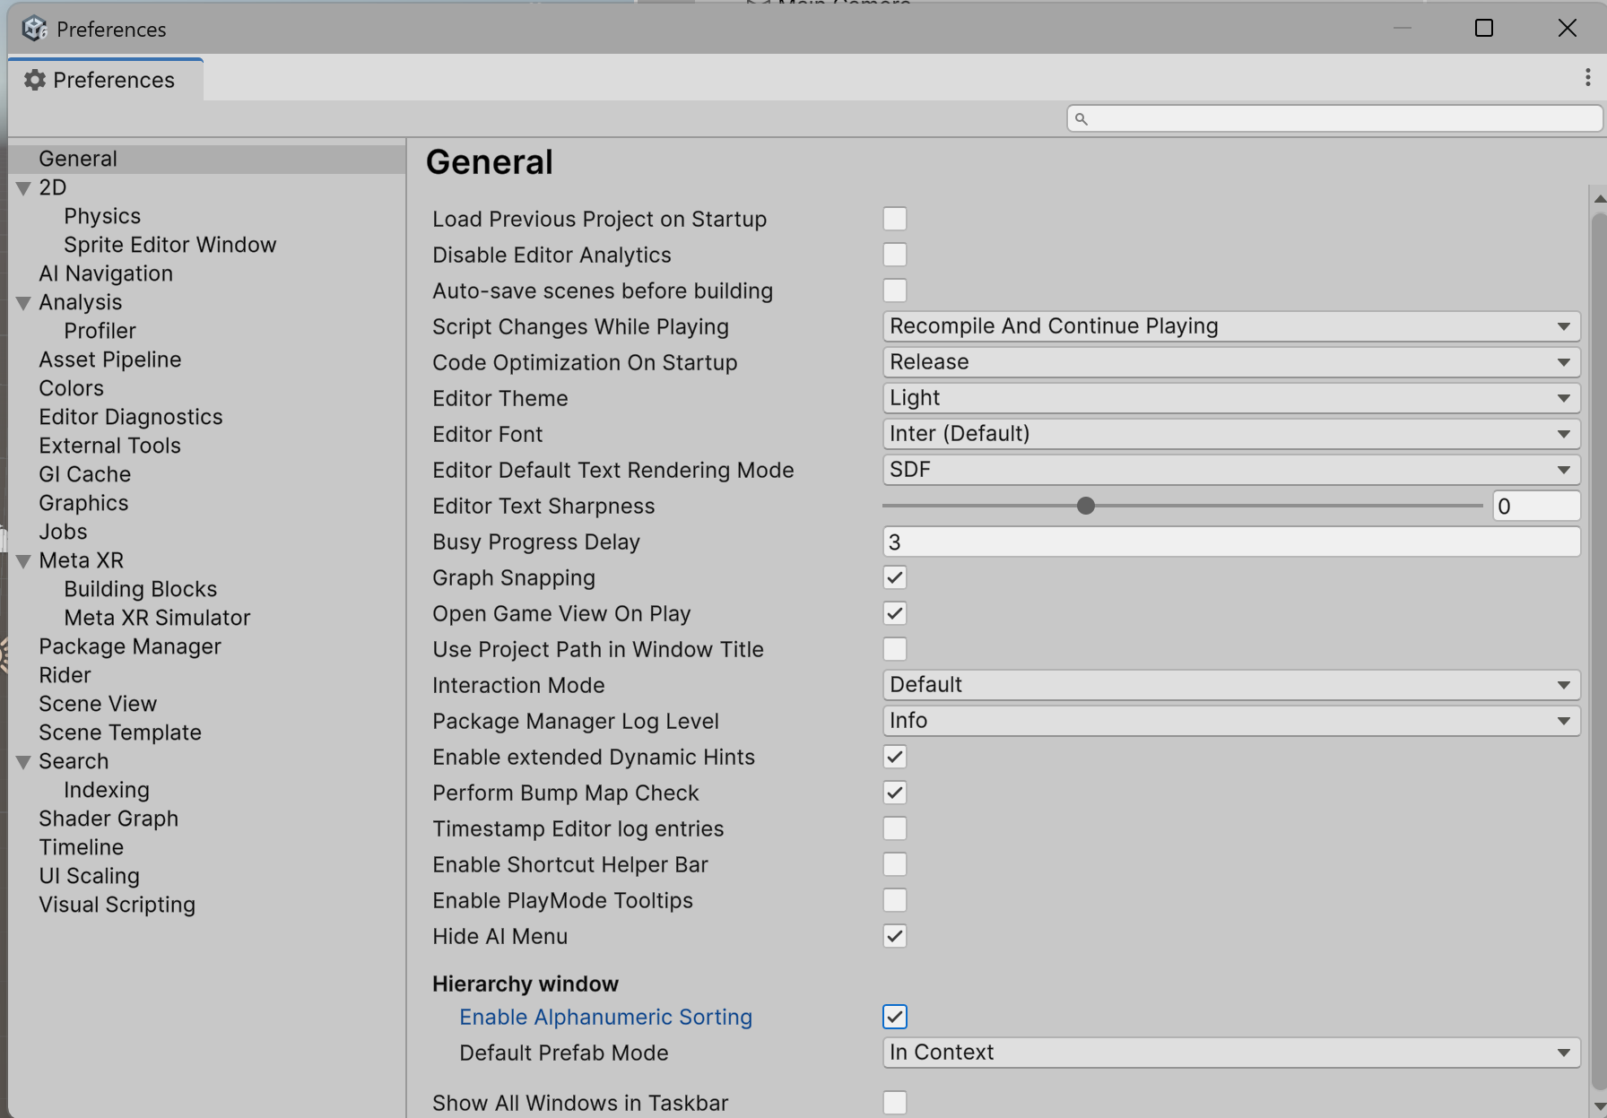

Make sure every categorized object has 0 position and 0 rotation.

**Categorization**

* Hierarchy and Asset organization
  + Uses prefix to keep these objects on top such as [] or _
  + _MANAGERS
    - Game Manager, Audio Manager, non-visual objects, etc.
  + _ENVIRONMENT
    - Static_Geometry
      * Large scale non-moving objects like Wall, Rocks, Houses, etc.
    - Dynamic_Geometry
    - Static_Props
      * Set dressing non-moving small objects like tools, books, etc.
    - Dynamic_Props
    - Terrain
  + _LIGHTING
    - Directional Light, Point Light etc.
  + _GAMEPLAY
    - Player Interactable objects, Quest related, etc.
  + _CAMERA
    - Rig, other cameras

**Asset Categorization**

* Create project name folder to separate assets and packages.
  + _HalloweenVR, _Store, _ThirdParty.

**Core Subfolders:** Inside root folder, create a standard set of subfolders.

* _Scenes
  + For all scene files (.unity).
* _Scripts
  + For all C# scripts. Can be sub-divided (e.g., Gameplay, UI, Tools).
* _Art
  + A master folder for all visual assets.
    - Materials: All .mat files.
    - Models: All .fbx or .obj files. Often organized by type (e.g., Props, Architecture, Characters).
    - Textures: All .png, .tga, .jpg files.
    - Shaders: Custom shaders and graphs.
* _Audio
  + A master folder for sound.
  + SFX: Sound effects.
  + Music: Music tracks.
* _Prefabs
  + For all prefab files. This is one of the most important folders.
* _Animations
  + Animation controllers and clips.

**Make sure these “Static” objects has checked Static in the inspector. Always check the object to see if it’s static or not**

You can snap the vertex of the object to other objects by **Holding “V”** and drag the center to the other object you want to snap to.

**Press “H”** will hide / unhide the selected object.

**Press "Shift+H”** to isolate/Un-isolate the selected object (Hide all other objects).

Create “Terrain” and put this terrain object into environment. It’s already a static object so we don’t need to set anything.

Terrain will have different sets of options to use**. (Follow the Class Lecture)**

* Paint terrain
* Paint texture
* Paint tree
* Paint detail
* Terrain settings

